Marilaura Alvarado Navarro

Task 15

2024

1. PART

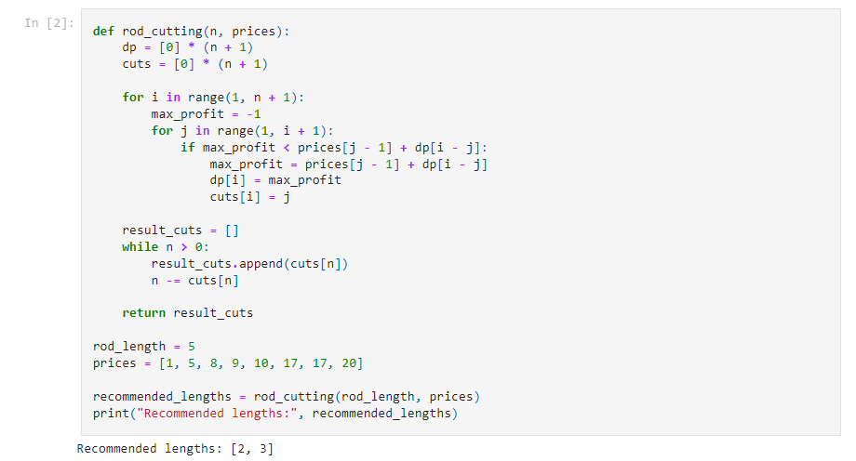

**Conclusions:** Here I wrote this code that effectively solves the rod cutting problem. It calculates the optimal way to cut a rod of a given length into smaller pieces to maximize the total revenue. The code iteratively computes the maximum profit for each possible rod length by considering all potential cut positions.

1. PART

Notebook 11

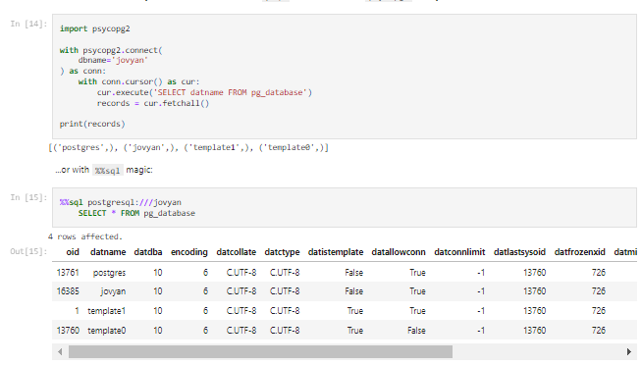

Notebook 12

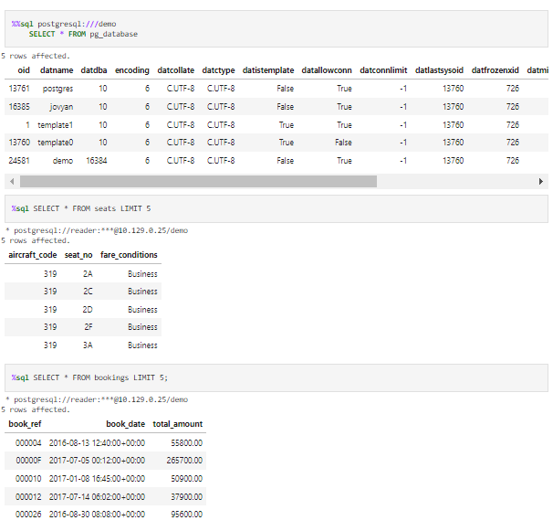

**Conclusions:**

**2.3 Conclusion:** The SQL query successfully retrieved the first five rows of data from the seats table. This query demonstrates the effectiveness of the 12th notebook type of connection. By using this method, in my opinion more direct control over the database connection, allowing for greater flexibility and customization, than when I tried connection of 11th manual

**2.4 Conclusion:** I was able to successfully use an SQL query to find information about the passenger who used ticket number '0005432312164'. By combining data from different tables, I was able to figure out that the passenger's name is Aleksey Gerasimov and I also found details about their flights, like where they flew from and to, and how much each flight cost. This information could be helpful for understanding customer behavior, tracking travel history, or even spotting suspicious activity.